
News release
For immediate release

SPRING BREAK 2025 IN THE EASTERN TOWNSHIPS
A MULTITUDE OF ACTIVITIES AND ATTRACTIONS!

Sherbrooke, February 20, 2025 – In the Eastern Townships, winter is well under way! More than 300 cm of snow have already fallen at our four major ski resorts, creating the ideal conditions for winter lovers, amid the spectacular landscapes for which the region is renowned. In addition to snow sports, the Townships offers endless opportunities to enjoy activities such as forest hikes, outings with the family and gourmet getaways.
During the 2025 Spring Break, the choice of attractions ranges from snowy slopes, to wellness centres and restaurants offering fine dining. In other words, something for everyone! The region’s tourism businesses have come up with a number of exciting programs for what is always an eagerly-awaited break in the winter and they’re offering a multitude of experiences designed to appeal to every age…
Winter on the slopes
Our major ski resorts are blessed with abundant snow and breathtaking scenery – that goes without saying – but each centre offers something a little different. The L’Est Go “passport” gives access to them all, allowing you to explore their unique personalities. Armed with this card, visitors can sample the famous glade runs at Mont SUTTON, extend their skiing hours into the evening at Bromont, montagne d’expériences (the slopes are illuminated), experience the stunning views over Lake Memphremagog from Owl’s Head and the challenging trails down Mont Orford. Not only that, card holders save up to 38% on the cost of regular ski passes!
This season, the Townships’ ski stations are enjoying optimal skiing conditions thanks to state-of-the-art snowmaking machines, the diligent work of onsite crews and Mother Nature! What better time to enjoy our mountains than during the spring break?
And they will be lively places for those who like a bit of action! Mont Orford has come up with fun events for the Spring Break – an alpine hike with a bar, at the summit of the mountain (February 28), a family-oriented day on March 4 and a high-energy performance by Les Cool Brothers Band on March 8.
Owl’s Head offers a magical interlude for small fry by organizing an “owl hunt” and showing a movie guaranteed to tug at the heart strings! Their parents can enjoy après-ski with musical entertainment on the two Saturday nights of the Spring Break – March 1 and March 8.

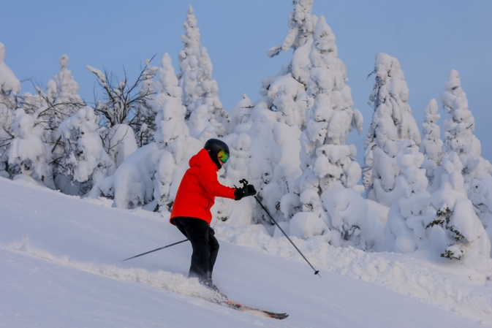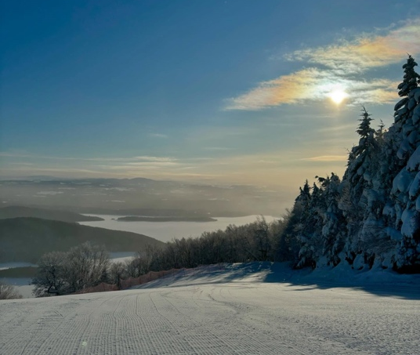
Crédit photo : Mont-Orford, 2 février 2025 Crédit photo : Owl’s Head, 5 février 2025
Mont SUTTON is going to town with no fewer than four weeks for festivities! The first two weeks, coinciding with the U.S. Spring Break (until March 2) includes a mega treasure hunt, karaoke evenings and four-day ski camps for kids (aged 6-13). The Quebec Spring Break is also organizing its own treasure hunt, musical performances and a party to celebrate the Bar Le Tucker’s 18th anniversary. The festivities continue during the Ontario Spring Break (March 8-16).
Bromont, montagne d'expériences is organizing a range of activities themed around mountain sports – treasure hunts on the ski trails, mini Olympic Games and encounters with the resort’s mascots, Grizzly and Lola – a week of outdoor fun for the entire family!
Located just 30 minutes from the town of Lac Megantic, Station Mont Ste-Cécile has launched a brand-new program of ski touring – a fast growing sport just waiting to be discovered!
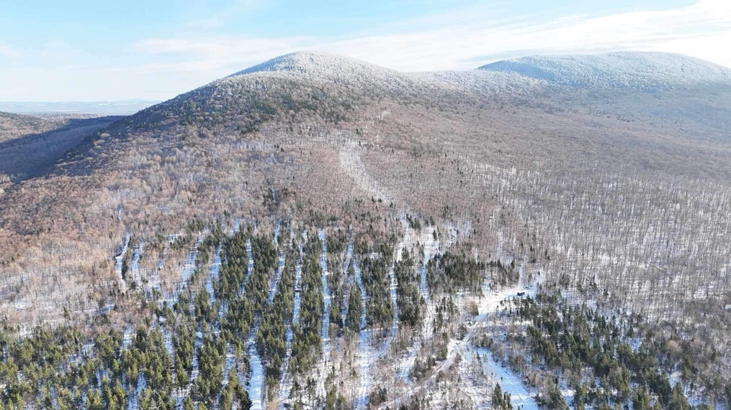
Crédit photo : Mont Ste-Cécile
Family-friendly activities in the great outdoors
On March 1, Parc de la Gorge de Coaticook is inviting families to enjoy an action-packed day of festivities – dog sledding, sweet treats from a mobile sugar shack, face painting for kids and magical tales around the fire, narrated by staff from the Bibliothèque Françoise-Maurice Library.
Jouvence, in the heart of Mont Orford National Park, is offering an all-inclusive package that includes immersive family activities and tasty buffet meals – a guarantee of memorable experiences in the great outdoors! (March 1-7.)
The Marais de la Rivière-aux-Cerises marsh is running an interesting, varied program during the spring break. The week kicks off on March 1 with a fascinating lecture about Quebec’s birds of prey, their hunting techniques and how some species are endangered. On March 5, there will be a « Spring Break Rally “ – a fun search along the trails featuring the animals who live in the Marsh and brave the rigours of the winter months. The highlight of the week is a magical family event on March 8 - a fantastical tale about Billy the Bear, narrated by storyteller Nathalie Matte. And don’t miss Momenti a new immersive exhibition showcasing the rich biodiversity of the marsh.
Youngsters with a sense of adventure will have a field day at the nature day camp being run by the Centre d’interprétation de la nature du lac Boivin in Granby. During their stay, they’ll learn all about the local insects, mammals and birds, topped off with delicious maple taffy on snow (ages 5-7).
(NOTE : FIN DES INSCRIPTIONS LE LUNDI 24 FÉVRIER, SUPPRIMER SI ON PUBLIE APRÈS)
Mont Megantic National Park is once again running its annual “Semaine blanche” (“White week”) with a slew of family activities (March 1-9). The highlight will be the Journée de la famille (Family Day) on March 6. Visitors will be offered (free of charge) access to the snowshoe trails, slides, inflatable games and telescopic observations of the sun. Maple taffy on snow will also be part of the festivities. For those who love observing the planets, there will also be “Astronomy Evenings” at the ASTROlab, which culminate in a magical hike under the stars by the light of flaming torches! (There is no charge for children 17 years old and under.)
Adventures in food!
For those who love traditional food in a traditional setting, La Ferme des petits Torrieux offers a memorable experience off the beaten track – a visit with the farm animals, a sugar shack meal and the opportunity to interact with one of the horses with a demonstration of the commands that control this mighty animal – an insight into a different world and educational at the same time! And in nearby Lac Megantic, Plaisir sans faim, a new dairy bar, anticipating the start of a warmer season, will open on March 6.

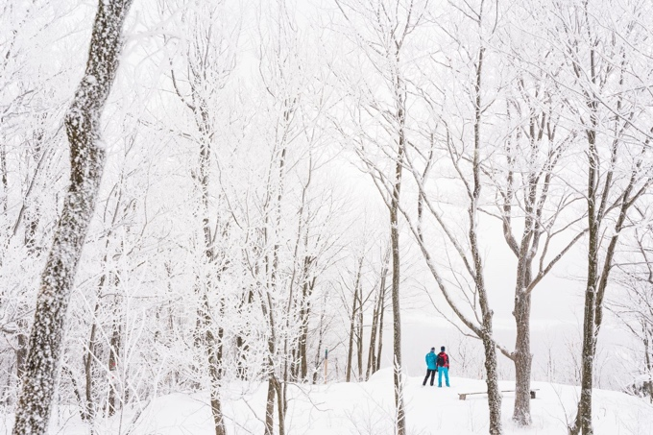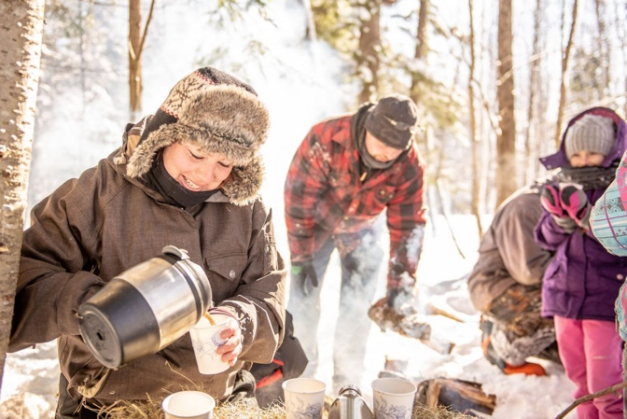
Crédit photo : Charles Dion Crédit photo : Ferme des petits Torrieux
Forests of the imagination…
After a day in the outdoors, warm up with a couple of indoor games at Camping Aventure Mégantic. In addition to being a campsite, this venue offers a couple of “escape rooms” where participants can imagine themselves in an Amazon rainforest or “play detective” as they track down a stolen work of art.
An imaginary forest is also a feature of the special programming for the Spring Break at the Musée des beaux-art (Fine Arts Museum) in Sherbrooke (March 1-9). Museum-goers can participate in 30 activities themed around a couple of exhibitions – “Balade en forêt” (“Forest Walk”) and “Lignes de feu” (“Lines of Fire”).

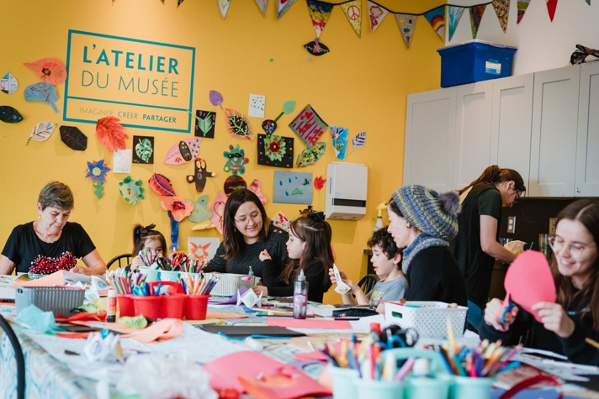
Crédit photo : Jean-Michel Nault
More family fun !
During the spring break, families can participate in the free indoor and outdoor activities organized by the Municipality of Lambton. On offer are bingo games, movies and ice hockey (to name a few). Visitors also have access to the rental equipment, tubing, snowshoes and sleds at no charge.
The Musée de la nature et des sciences, Sherbrooke’s Museum of Nature and Science, is offering a host of exciting activities throughout the spring break - fiery demonstrations of how to create dry ice (through chemical reactions), science exhibits and an educational visit to the animals who live at the Educazoo.
Opened a year ago, Granby’s P’tit monde des grands is an imaginative museum for kids, housing scaled-down versions of things that society interacts with every day - a restaurant, a police car, a grocery store…. Families who visit the museum, are eligible for two “trips” on the mock-up of an airplane flight deck. Reservations must be made in advance.
Relaxation and wellness
Need a break? Strøm spa nordique in Sherbrooke is once again offering its Børn family mornings (thermal experience) from March 3-6 (ages 5 and older), as well as its Drøm evenings designed for 12-17 year olds, accompanied by their parents.

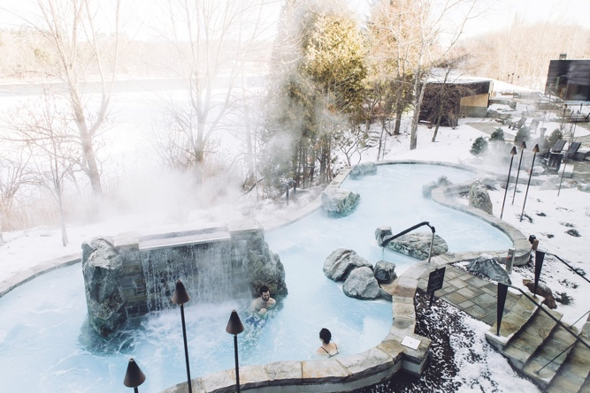
Crédit photo : Strøm spa nordique Crédit photo : Strøm spa nordique

In Bromont, the BALNEA spa + reserve thermale wellness centre is welcoming families over the spring break. From February 28 – March 9, youngsters (aged 12 and older) can enjoy the facilities if accompanied by an adult. Younger kids (8-11) can also enjoy the thermal facilities on three consecutive mornings – March 4, 5 and 6) but reservations must be made in advance.

Spa Bolton also welcomes families! Enjoy the relaxing ambience with your youngsters (aged 7-11) by booking a“Rise and Shine Parent-Child Morning”. On weekdays, students are eligible for discounts.
Hébergement aux Cinq Sens in Piopolis is owned by a couple whose heritage is Canada’s First Nations and they create personalized, immersive experiences for those seeking authentic experiences in harmony with Mother Nature (ages 16 and older).
For more suggestions on spring break activities, check out:
Special Feature School Break
What to do during during the spring break

About Tourism Eastern Townships
Tourisme Cantons-de-l’Est (Tourism Eastern Townships) is one of 21 tourism associations (ATRs) in Quebec and the official representative of Quebec's Ministry of Tourism in the Eastern Townships. Since 1978, the TCE’s mission has been to support and promote tourism development and market the region within Quebec and internationally. TCE brings together more than 600 members representing more than 1,000 tourism offerings throughout the 9 regional county municipalities (MRCs) and in all sectors of the tourism industry: accommodation, restaurants, attractions, activities and events.
The Eastern Townships is the fourth most popular tourist destination in Quebec. The region attracts some 10 million visitors every year, accounting for 6.5 million overnight stays and a tourism spend of more than $900 million annually. The industry generates more than 18,000 jobs, making the Eastern Townships the 4th largest tourism employer in the province of Quebec.
-30-

Source :
Shanny Hallé
Media Relations Coordinator | Tourism Eastern Townships
Cell : (819) 821-1220 | Email: shalle@atrce.com

