Press release
For immediate publication

2024 total solar eclipse: an affordable change of scenery in the
Eastern Townships
Sherbrooke, March 14th 2024 – As the highly anticipated total solar eclipse draws near, Tourism Eastern Townships invite US visitors to experience this unique astronomical event amidst the breathtaking backdrop of this Quebec’s region, nestled entirely within the centrality band. Located a mere 4 hours from Boston and just an hour's drive from Burlington, the Eastern Townships are one of the best places in North America to witness this historic phenomenon.
With less than a month to go before the eclipse, there's still plenty of accommodations available throughout the region, a perfect opportunity to discover this area close to you... but far from ordinaire.
Why come to the Townships to see the eclipse?
The Eastern Townships stands out as one of the few regions in Quebec that falls entirely within the path of totality of the eclipse, which will set above two dark sky reserves (Mont-Mégantic First International Dark Sky Reserve and Au Diable Vert, Canadian dark sky preserve), providing a unique opportunity for visitors to experience this phenomenon firsthand at one of the region's 40 designated observation sites. Here, the eclipse will last several uninterrupted minutes. Contrasting with the 45 seconds totality window in Montreal, the eclipse duration in the Townships will be an impressive 3 minutes and 30 seconds.

Local stakeholders are actively organizing a variety of activities throughout the Eastern Townships for the occasion. Tourism Eastern Townships has set up a dedicated web page where visitors can find all the information they need on the solar eclipse, including a detailed map of observation sites in the region, a directory of special events and activities, and many suggestions for extending their stay in the region. Visit easterntownships.org/2024eclipse
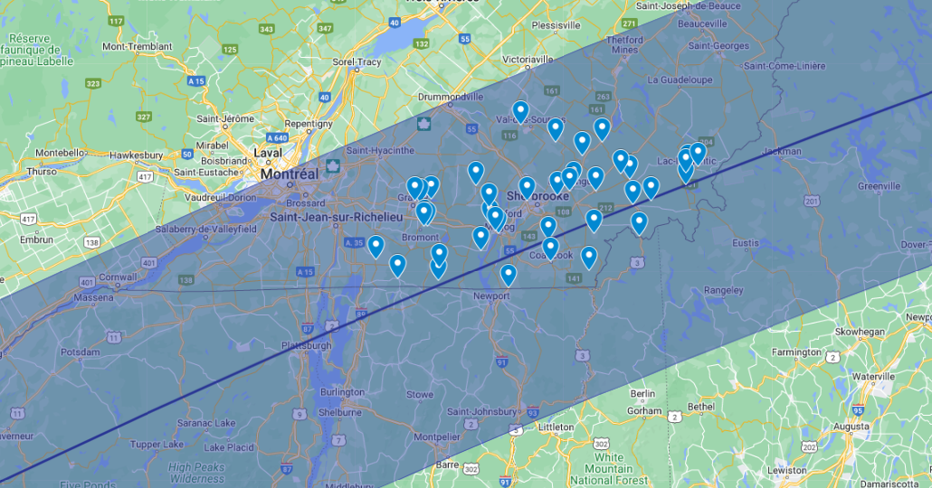
Path of the solar eclipse and observation sites in the Eastern Townships
A wide variety of lodging options
From charming hotels, cozy Bed and Breakfast, to unique options like tree houses, yurts, tipis or eco-lodges... a large variety of great yet affordable accommodations are still available in the Eastern Townships. ‘’While several U.S. cities within the eclipse's path of totality are either already fully booked or have limited availability, in the Eastern Townships, not only is there lodging still accessible, but it comes at a reasonable cost for those eager to explore our scenic region.’’ explains Isabelle Charlebois, General manager of the Eastern Townships Tourism Association. Thanks to the favorable exchange rate, a room priced at 200 $CAD translates to less than $150 USD, making it an even more enticing option for travelers.
To find ideas of accomodation options in the Eastern Townships, visit: https://www.easterntownships.org/where-to-stay
Extending your stay
Those seeking for gastronomy, culture, relaxation or adventure will be served. While April typically sees a quieter pace in the region, Tourism Eastern Townships has put together a number of itinerary ideas around some of the eclipse observation sites, where you'll also find many attractions, accommodations and restaurants open at that time, to help you discover the region's riches.

Sharing the US border with Vermont, New Hampshire and Maine, the area is boasting a unique blend of New England charm with a French twist and is known for its exceptional landscapes, world-class hospitality and flavours unique to its rich terroir. The region is a year-round destination and a huge hub for outdoor adventures, offering also numerous activities for the whole family. With over 30 microbreweries, dozen of cheese factories (part of the Circuit des Têtes Fromagères), 40 wineries and a Wine Route (it is the cradle of viticulture in Québec), the region is a mecca for gourmets and those who appreciate fresh, tasty, local food. You can sample these regional goodies in any of the Cafés de village, as well as at our many fine dining establishments.

To help plan a visit…
To find out all about the eclipse...in the Townships: easterntownships.org/2024eclipse
Further information about the solar eclipse: Éclipse Totale de Soleil eclipsequebec.ca
Further information about the region: Tourism Eastern Townships

About Tourism Eastern Townships
Tourisme Cantons-de-l’Est (Tourism Eastern Townships) is one of 21 tourism associations (ATRs) in Quebec and the official representative of Quebec's Ministry of Tourism in the Eastern Townships. Since 1978, the TCE’s mission has been to promote tourism development, marketing the region within Quebec and internationally. TCE brings together more than 600 members representing more than 1,000 tourism offerings throughout the 9 regional county municipalities (MRCs) and in all sectors of the tourism industry: accommodation, restaurants, attractions, activities and events.
The Eastern Townships is the fourth most popular tourist destination in Quebec. The region attracts some 10 million visitors every year, accounting for 6.5 million overnight stays and a tourism spend of more than $900 million annually. The tourism sector is also the region’s fourth largest employer, accounting for 18,000 jobs.
-30-
Source : Shanny Hallé
Media relations
Tourism Eastern Townships
Cell: (819) 821-1220 | Email : shalle@atrce.com

